**Blinkit Data Analysis Project**

DAY 1 (9-6-25)

**See all the data imported:**

SELECT * FROM blinkit_data

**DATA CLEANING:**

Cleaning the **Item_Fat_Content** field ensures data consistency and accuracy in analysis.  
The presence of multiple variations of the same category (e.g., LF, low fat vs. Low Fat) can cause issues in reporting, aggregations, and filtering. By standardizing these values, we improve data quality, making it easier to generate insights and maintain uniformity in our datasets.

UPDATE blinkit_data

SET Item_Fat_Content =

CASE

WHEN Item_Fat_Content IN ('LF', 'low fat') THEN 'Low Fat'

WHEN Item_Fat_Content = 'reg' THEN 'Regular'

ELSE Item_Fat_Content

END;

After executing this query check the data has been cleaned or not using below query:

sql

SELECT DISTINCT Item_Fat_Content FROM blinkit_data;

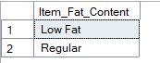

**A KPI’s**

1. **TOTAL_SALES:**

SELECT CAST(SUM(Sales)/1000000.0 AS DECIMAL(10,2)) AS Sales_Millions

FROM blinkit_data;



1. **AVERAGE_SALES:**

SELECT CAST(AVG(Total_Sales) AS DECIMAL(10,0)) AS Avg_Sales

FROM blinkit_data;

DAY 2 (10-6-25)

1. **NUMBER_OF_TEMS:**

SELECT COUNT(*) AS No_Of_Items

FROM blinkit_data

1. **AVERAGE OF RATING :**

SELECT CAST(AVG(Rating) AS DECIMAL(10,2)) AS Avg_Rating From blinkit_data

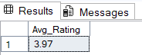

1. **AGGREGATE OVER ITEM FAT CONTENT :**

SELECT Item_Fat_Content,

CAST(SUM(Sales) AS DECIMAL(10,2)) AS Sales,

CAST(AVG(Sales) AS DECIMAL(10,1)) AS Avg_Sales,

COUNT(*) AS No_Of_Items,

CAST(AVG(Rating) AS DECIMAL(10,2)) AS Avg_Rating

FROM blinkit_data

GROUP BY Item_Fat_Content

ORDER BY Sales DESC

1. **AGGREGATE OVER ITEM TYPE :**

SELECT Item_Type,

CAST(SUM(Sales) AS DECIMAL(10,2)) AS Sales,

CAST(AVG(Sales) AS DECIMAL(10,1)) AS Avg_Sales,

COUNT(*) AS No_Of_Items,

CAST(AVG(Rating) AS DECIMAL(10,2)) AS Avg_Rating

FROM blinkit_data

GROUP BY Item_Type

ORDER BY Sales DESC

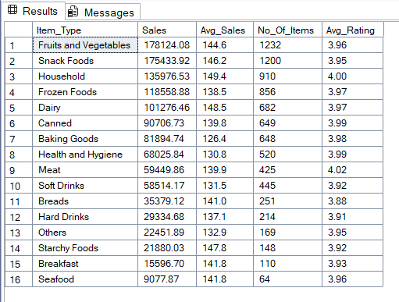

**F. Percentage of Sales by Outlet Size**

SELECT

Outlet_Size,

CAST(SUM(Sales) AS DECIMAL(10,2)) AS Sales,

CAST((SUM(Sales) * 100.0 / SUM(SUM(Sales)) OVER()) AS DECIMAL(10,2)) AS Sales_Percentage

FROM blinkit_data

GROUP BY Outlet_Size

ORDER BY Sales DESC;

**Sales by Outlet Location**

SELECT Outlet_Location_Type,

CAST(SUM(Sales) AS DECIMAL(10,2)) AS Sales,

CAST((SUM(Sales) * 100.0 / SUM(SUM(Sales)) OVER()) AS DECIMAL(10,2)) AS Sales_Percentage,

CAST(AVG(Sales) AS DECIMAL(10,1)) AS Avg_Sales,

COUNT(*) AS No_Of_Items,

CAST(AVG(Rating) AS DECIMAL(10,2)) AS Avg_Rating

FROM blinkit_data

GROUP BY Outlet_Location_Type

ORDER BY Sales DESC

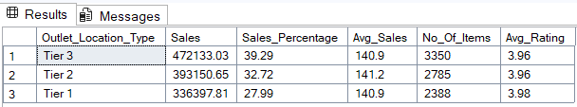

**Sales by Outlet Type**

SELECT Outlet_ Type,

CAST(SUM(Sales) AS DECIMAL(10,2)) AS Sales,

CAST((SUM(Sales) * 100.0 / SUM(SUM(Sales)) OVER()) AS DECIMAL(10,2)) AS Sales_Percentage,

CAST(AVG(Sales) AS DECIMAL(10,1)) AS Avg_Sales,

COUNT(*) AS No_Of_Items,

CAST(AVG(Rating) AS DECIMAL(10,2)) AS Avg_Rating

FROM blinkit_data

GROUP BY Outlet_Type

ORDER BY Sales DESC

